2210:

Red & Green foods classification:

2211

Red & Green foods classification:

Result:

2215:

Red & Green foods classification:

Result:

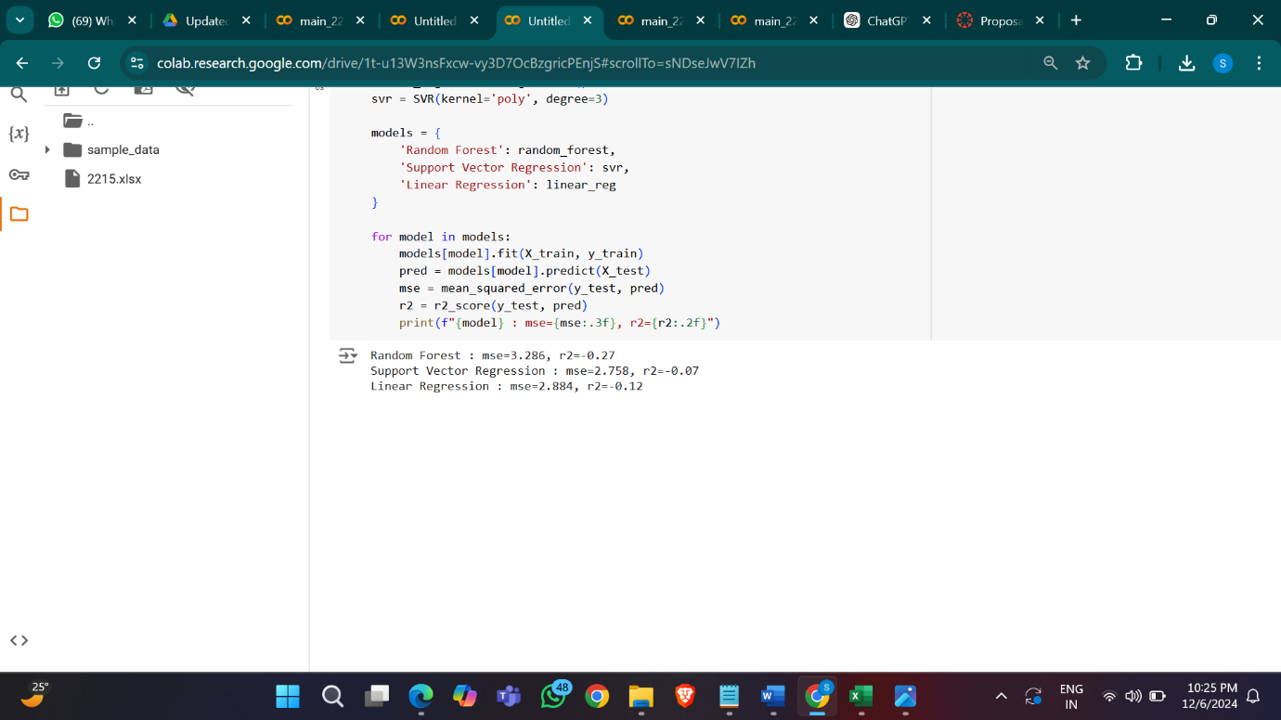

2218

Red & Green foods classification:

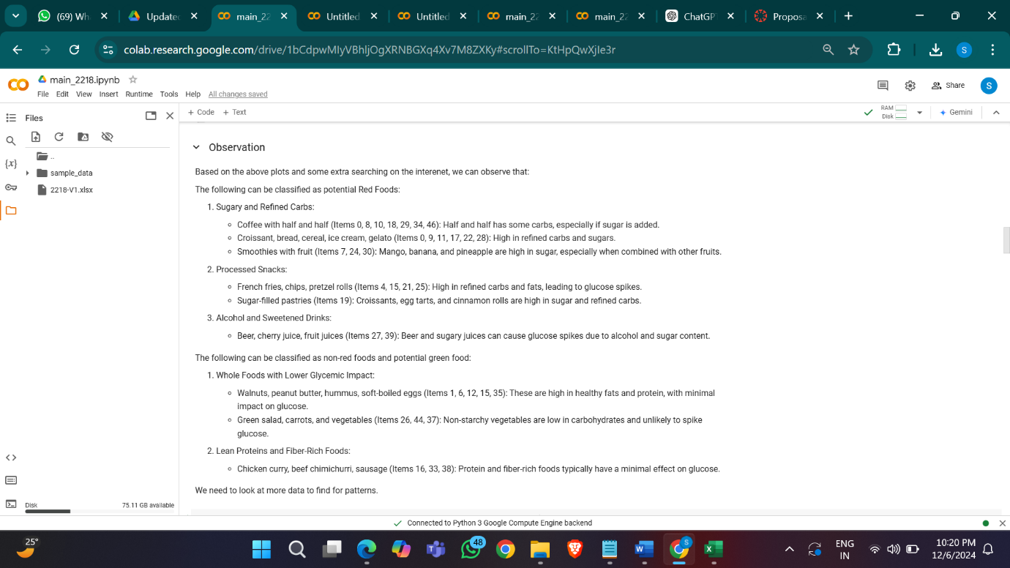

Result:

2221:

Red & Green foods classification:

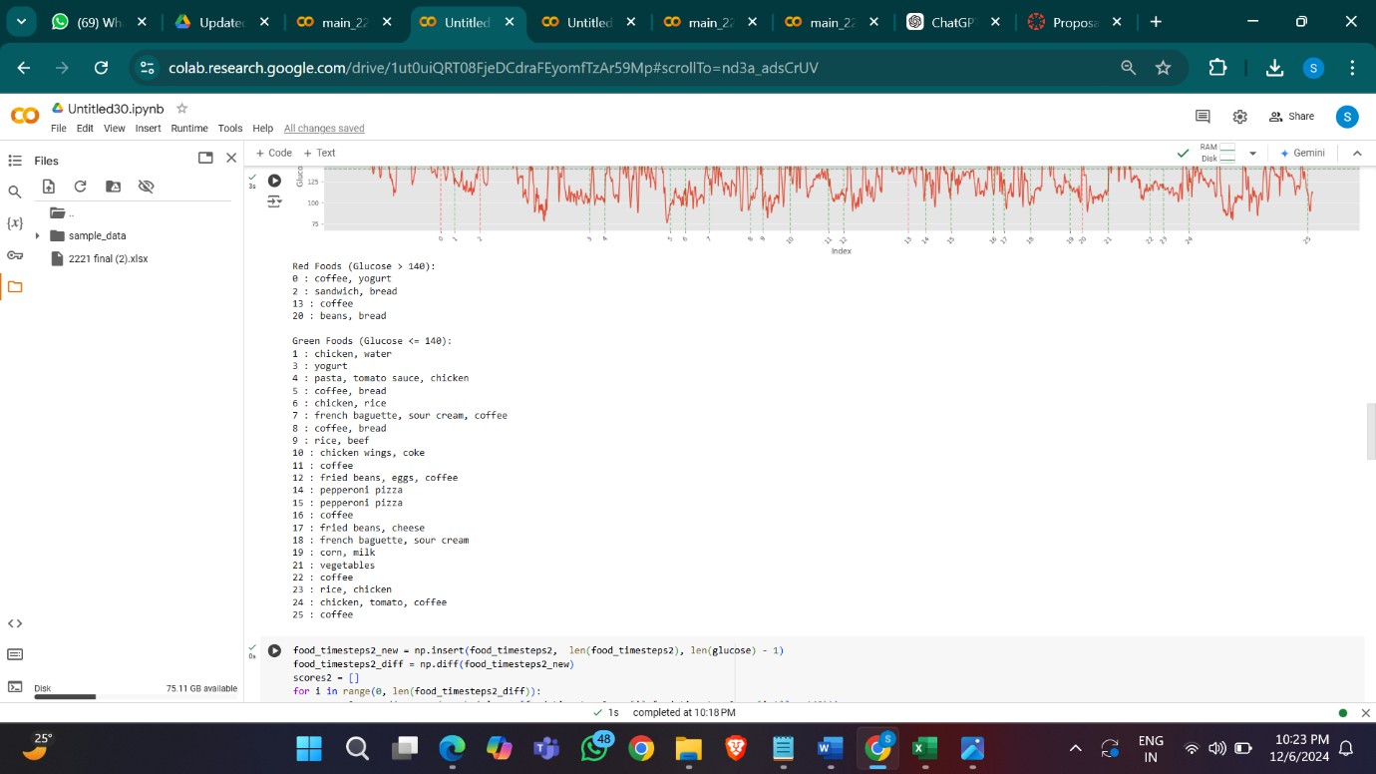

Result:

